USER INTERFACE AND DESIGN EXPERIMENT – 10
Name: Swetha R Roll No: 240701550

AIM:
The aim is to create data visualizations, such as pie charts and bar graphs, for an inventory management system using JavaScript.

PROCEDURE:
Step 1: Set Up Your HTML File
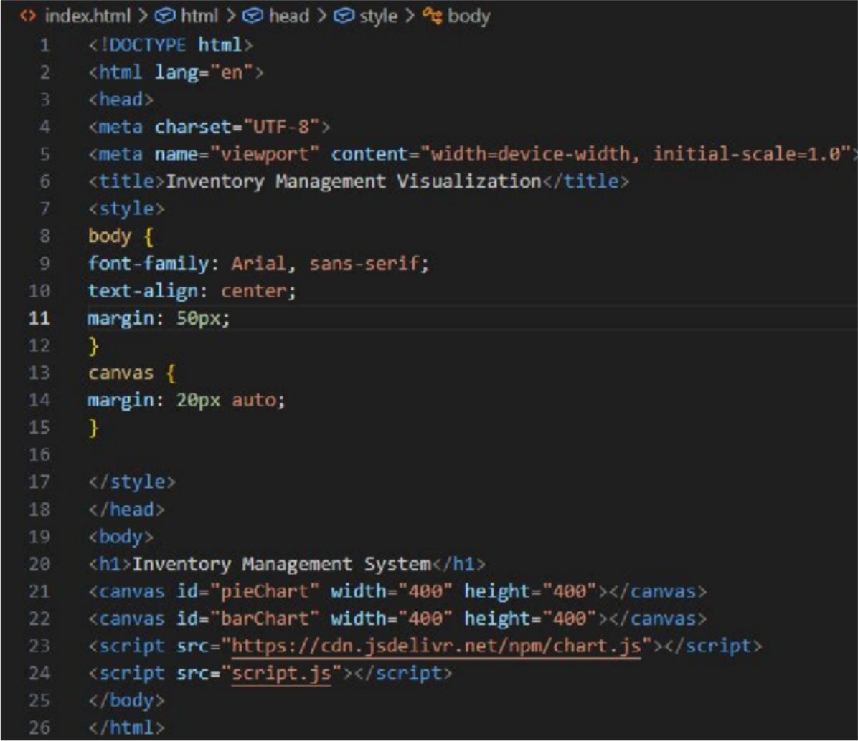

Step 2:
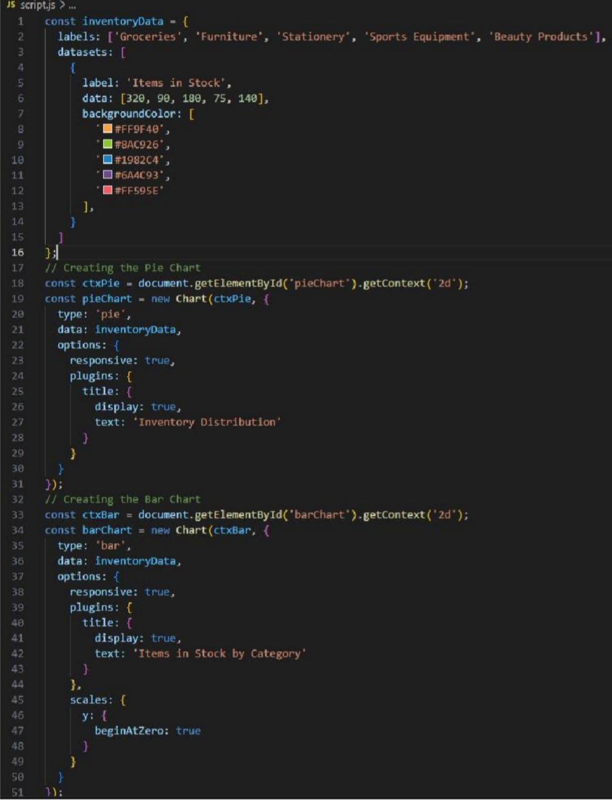
Create the JavaScript File for Charts Next, create a JavaScript file (script.js) to handle the data visualization logic.

OUTPUT:

